
ENGREG HIGH SCHOOL
24, Bankole Street, Pedro, Shomolu, Lagos
WEEK: 6 FIRST TERM SESSION: 2024/2025
SUBJECT: COMPUTER STUDIES |  | TOPIC: ALTERNATIVE LOGIC GATES TRUTH TABLES
CLASS: SS 2 | DATE: 14th – 18th October, 2024. | REFERENCE BOOKS: New Computer Studies for SS 2 by J.O.E Otuka et al Pages 14-16  Online with computers for SS 2 by Adedapo F. O. et al 17 - 21
LEARNING PURPOSE:  To provide foundational knowledge on the uses of alternative logic gates and the truth table for alternative logic gates and derived logic gates. |  |  |  | LESSON PERIOD: 1  DURATION: 40 MINS
LEARNING OBJECTIVE: By the end of the lesson, students will be able to:  - Draw a 2,3 input truth table of Alternative Logic Gates.  - Draw a 2,3 input truth table of Derived Logic gates.  - State the uses of alternative logic gates. |  |  |  | KEYWORDS:  Logic Gates, Derived, Alternative, Symbol, Boolean Expression.
PREVIOUS LEARNING: The students are familiar with the truth table and uses of Basic Logic Gates. |  | INSTRUCTIONAL MATERIALS:  Interactive board, computer system, Internet
LEARNING ACTIVITIES IN STEPS:  Step 1: The teacher marks assignment and makes correction.  Step 2: The teacher asks questions on previous knowledge  Step 3: The teacher modifies students’ response and introduces the new topic  Step 4: Students would be taken through the derailed explanation of the lesson content  Step 5: Students ask questions on the content of the lesson  Step 6: Students would be evaluated based on behavioral objectives  Step 7: Students Assignments are given and notes are marked |  |  | LEARNING TIME FOR EACH STEP:  Step 1: 3mins  Step 2: 2mins  Step 3: 3mins  Step 4: 20mins  Step 5: 2mins  Step 6: 7mins  Step 7: 3mins
LEARNING SKILLS:  Critical thinking, creative thinking, communicating and leadership development |  | ACTIVITY  - Draw a 2 and 3 input truth table of the NOR and NAND Logic Gates.
EVALUATIVE QUESTIONS:  - Draw a 2,3 input truth table of Alternative Logic Gates.  - Draw a 2,3 input truth table of Derived Logic gates.  - State five uses of alternative logic gates. |  | ASSIGNMENT  - Draw a 2 and 3 input truth table of XOR and XNOR Logic gates.  - State three uses of alternative logic gates.

ALTERNATIVE LOGIC GATES TRUTH TABLES

Summary for all NOR 2-input gates
A | B | P
0 | 0 | 1
0 | 1 | 0
1 | 0 | 0
1 | 1 | 0

Summary for all NOR 3-input gates
A | B | C | P
0 | 0 | 0 | 1
0 | 0 | 1 | 0
0 | 1 | 0 | 0
0 | 1 | 1 | 0
1 | 0 | 0 | 0
1 | 0 | 1 | 0
1 | 1 | 0 | 0
1 | 1 | 1 | 0

Summary for all NAND 2-input gates
A | B | P
0 | 0 | 1
0 | 1 | 1
1 | 0 | 1
1 | 1 | 0

Summary for all NAND 3-input gates
A | B | C | P
0 | 0 | 0 | 1
0 | 0 | 1 | 1
0 | 1 | 0 | 1
0 | 1 | 1 | 1
1 | 0 | 0 | 1
1 | 0 | 1 | 1
1 | 1 | 0 | 1
1 | 1 | 1 | 0

USES OF ALTERNATIVE LOGIC GATES
- Reduce energy loss by recovering input states.
- Perform operations on qubits for advanced computations.
- Use light signals for faster data transmission.
- Process three logic states for improved data handling.
- Use biological molecules for computations in bioengineering.
- Apply mechanical components in decision-making systems for specialized environments.

DERIVED LOGIC GATES TRUTH TABLES

Summary for all XOR 2-input gates
A | B | R
0 | 0 | 0
0 | 1 | 1
1 | 0 | 1
1 | 1 | 0

Summary for all XNOR 2-input gates
A | B | R
0 | 0 | 1
0 | 1 | 0
1 | 0 | 0
1 | 1 | 1

ENGREG HIGH SCHOOL
24, Bankole Street, Pedro, Shomolu, Lagos
WEEK: 6 FIRST TERM SESSION: 2024/2025
SUBJECT: COMPUTER STUDIES |  | TOPIC: IEC SYMBOLS
CLASS: SS 2 | DATE: 14th – 18th October, 2024. | REFERENCE BOOKS: New Computer Studies for SS 2 by J.O.E Otuka et al Pages 14-16  Online with computers for SS 2 by Adedapo F. O. et al 17 - 21
LEARNING PURPOSE:  To provide foundational knowledge on IEC symbols and Digital Comparators. |  |  |  | LESSON PERIOD: 2  DURATION: 40 MINS
LEARNING OBJECTIVE: By the end of the lesson, students will be able to:  - Explain the IEC symbol.  - Draw the IEC symbols for the logic gates.  - Explain Digital Comparator.  - Draw a Comparator Truth Table. |  |  |  | KEYWORDS:  Logic Gates, Derived, Alternative, Symbol, Boolean Expression, IEC, Comparator.
PREVIOUS LEARNING: The students are familiar with the symbols and truth tables of the Logic gates. |  | INSTRUCTIONAL MATERIALS:  Interactive board, computer system, Internet
LEARNING ACTIVITIES IN STEPS:  Step 1: The teacher marks assignment and makes correction.  Step 2: The teacher asks questions on previous knowledge  Step 3: The teacher modifies students’ response and introduces the new topic  Step 4: Students would be taken through the derailed explanation of the lesson content  Step 5: Students ask questions on the content of the lesson  Step 6: Students would be evaluated based on behavioral objectives  Step 7: Students Assignments are given and notes are marked |  |  | LEARNING TIME FOR EACH STEP:  Step 1: 3mins  Step 2: 2mins  Step 3: 3mins  Step 4: 20mins  Step 5: 2mins  Step 6: 7mins  Step 7: 3mins
LEARNING SKILLS:  Critical thinking, creative thinking, communicating and leadership development |  | ACTIVITY  - Explain the IEC symbol.  - Draw the IEC symbols for the OR, AND and NOR logic gates.
EVALUATIVE QUESTIONS:  - Explain the IEC symbol.  - Draw the IEC symbols for the logic gates.  - Explain Digital Comparator.  - Draw a Comparator Truth Table. |  | ASSIGNMENT  - Explain Digital Comparator.  - Draw a Comparator Truth Table for 2 input.

IEC SYMBOLS
IEC (International Electrotechnical Commission) symbols are standardized graphical symbols used to represent electrical and electronic components in diagrams and schematics.
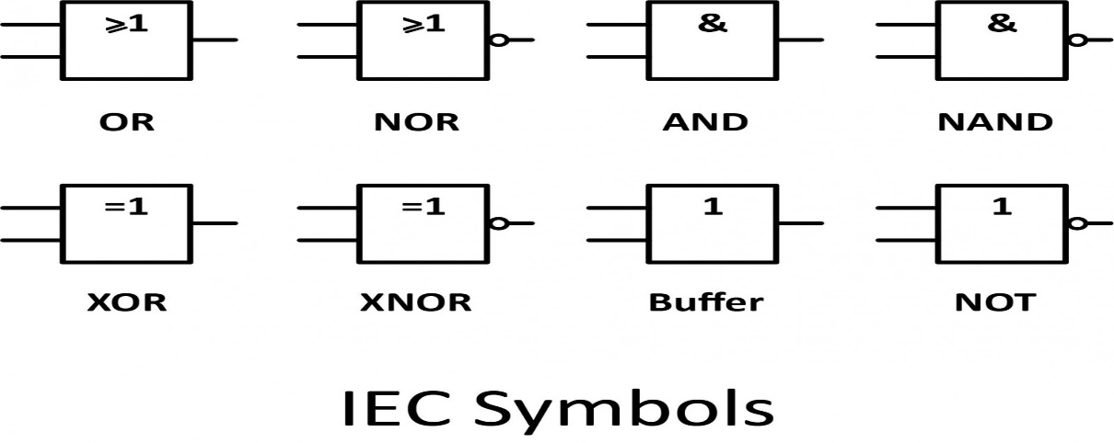

DIGITAL COMPARATOR
A digital comparator is an electronic device that takes two numbers as input in binary form and determines whether one number is greater than, less than or equal to the other number.
COMPARATOR TABLE
Example One.
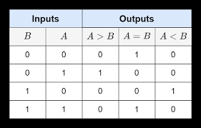
EXAMPLE TWO
